Kanban for Managing Many Small Tasks
Most project management methods are built for a few large, tightly coordinated projects. But what happens when your team faces hundreds or even thousands of small tasks over the course of a year?
In these high-variability environments, work changes quickly, and priorities shift often. Conventional planning methods break down. Managing this type of work requires a different approach: lightweight, dynamic, and visual.
The Nature of Small-Task Complexity
Knowledge workers typically juggle one or two large initiatives — a strategic sale, a major invention, or a financial merger. But alongside these, there are always dozens of smaller demands:
- Reviewing patent disclosures
- Approving invoices
- Responding to internal requests
- Patching a software bug
Individually, these tasks are simple. Collectively, they become overwhelming.
What makes them difficult is not just the volume:
- Many stakeholders can request them: Sales, Ops, HR, IT, etc.
- Scope often changes mid-stream, turning quick jobs into complicated ones
- Priorities are unclear, leading to conflict and overload
And yet, in many organizations, these tasks are left unmanaged — handed off with vague deadlines and minimal coordination.
“Immature plans and vague instructions are given out and the rest is left to those who implement them… Managers ignore their own shortcomings and bawl out subordinates.”
— Shigeo Shingo
Worse, these requests often exceed the team’s capacity, creating an unrationalized workload — where no reasonable amount of effort can meet expectations. The result is the waste of No-Win Contests: every stakeholder pushes their task forward, and everyone loses.

A Better Way
To manage a high volume of small tasks effectively, we need three shifts:
- Just-in-Time Rationalization
Don’t commit early. Delay the decision to do the work until just before you start. That minimizes rework caused by changing priorities.
- Ruthless Rationalization
Never accept more work than the team can deliver. Rationalization means negotiating either the scope or the resources — every time.
- Visual Flow Management
Use a Kanban board to make the work visible, track its flow, and limit what’s in progress.

Common Wastes When Rationalization Is Absent
Without a system for rationalizing workload, organizations fall into predictable patterns of waste.
- Work piles up uncontrollably
- Employees feel constantly behind
- Customers and stakeholders feel ignored
- Everyone compensates by pushing harder and shouting louder
It’s like a traffic jam on a freeway — gridlock everywhere, yet new vehicles keep entering. Teams feel overwhelmed, and no one gets what they need.

Case Example: A Developer’s No-Win Day
Consider Alexia, a web developer. She starts the day focused on a key deliverable — screen updates for an ad campaign Kim is managing that must go out by noon. This was delayed twice and now, there is no recovery if the work cannot be finished on time. Still, the job is manageable: two hours of work and there’s, four hours to get it done. But her plan unravels
- 8:00 AM — Clear the morning to make the screen updates for Kim by noon.
- 8:20 AM — A “critical” website bug is reported by John. It’s urgent, and she believes she can fix it in an hour.
- 9:30 AM — Rich drops by asking about an unrelated project. He's unhappy she hasn’t started it yet and spends 20 minutes of her morning.
- 10:00 AM — She finishes the fix on the US site, but the approach doesn’t work on the EU site. She has to start over.
- 10:30 AM — A customer call arrives about a security issue. She’s pulled in again.
- 12:30 PM — Kim, calls. The ad deadline is missed and they have to wait for the next ad cycle in two months.
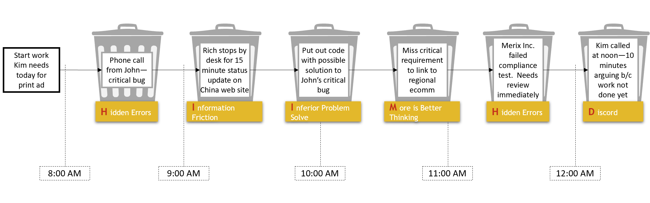
Figure 1. Examples of Waste in Non-Rationalized Work

What happened? John’s “urgent” bug had been live for months unnoticed. Kim’s deadline was immovable. But without visibility and clear priorities, Alexia didn’t know how to react to conflicting priorities from multiple people. This is the cost of unrationalized work.

Ruthless Rationalization
Ruthless Rationalization is a mindset: Do not agree to work that exceeds capacity.
It sounds obvious, even ethical. Agreeing to a deadline you know you can’t meet is a kind of misrepresentation. And yet, teams do it all the time.
Why? Because saying “no” is hard:
- The boss pushes
- The customer insists
- The loudest voice often wins
And that’s the problem — the system rewards forcefulness over logic. The solution is to build a visible, shared method of committing only to what can be done. That’s what rationalization creates.

Three Steps to Rationalize Work
- Set a Clear Goal
Define the result: tasks per week, revenue target, compliance deadline — framed in business value.
- Select the Work
Choose the set of tasks needed to meet the goal. Be specific.
- Check the Fit
Match resources to the work. If it doesn’t fit, act:
  - Renegotiate the goal
  - Add resources
  - Replace low-value work with higher-value alternatives
If the workload and capacity don’t match, stop and fix it.
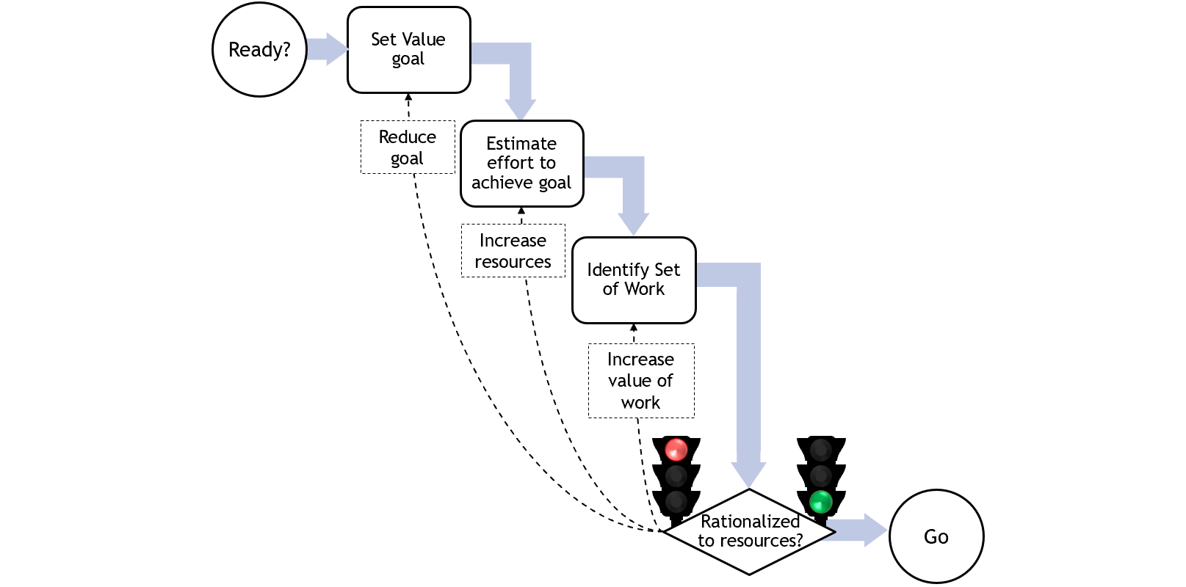
Figure 2. Ruthless Rationalization treats an unrationalized workload as a Stop-Fix alarm

Just-in-Time Rationalization
Ruthless Rationalization works best in environments with consistent team structure and clear ownership. But everyday work rarely fits that mold.
Teams often receive requests from:
- Product Marketing
- Operations
- Finance
- HR
- General Management
These groups don’t typically help weigh one another’s priorities — and often don’t even know they’re competing for the same resources.

Prioritize What Fits the Goal
Start with all incoming tasks. Assume they can’t all be done — that’s usually true.
Then:
- Rank tasks by value
- Fill up team capacity with the highest-value work
- Step back: Does the selected set meet organizational goals?
If yes — great.
If not — reselect, or escalate.
Don’t expect a spreadsheet to give you the answer. This requires judgment, not formulas.
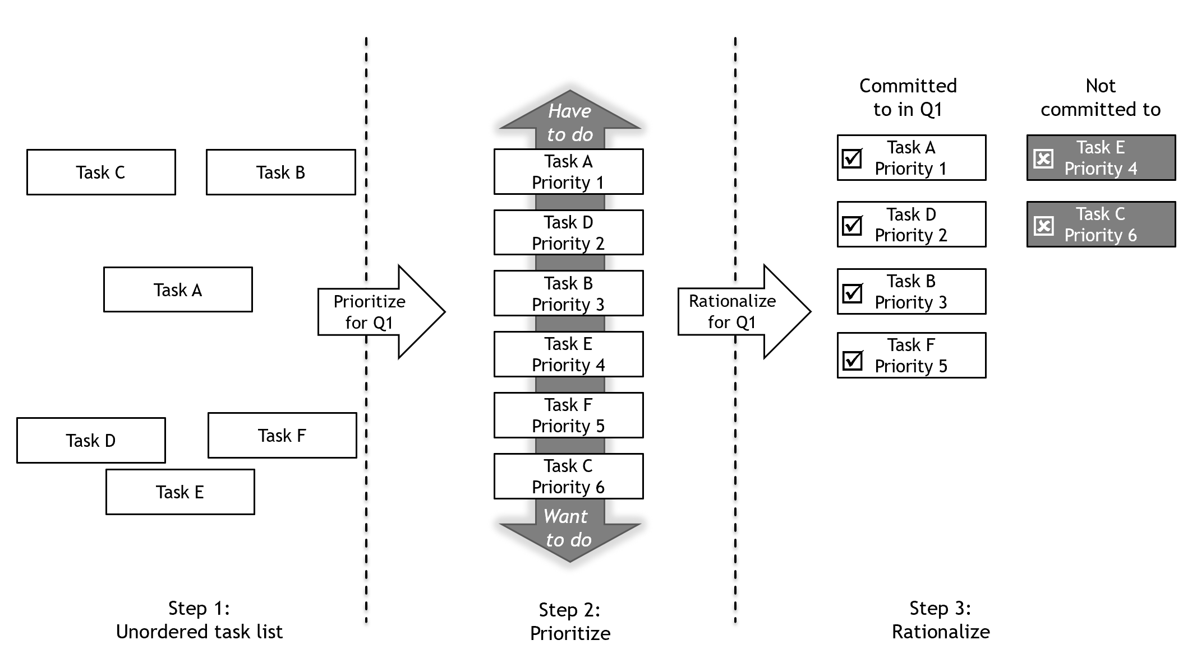
Figure 3. Rationalization is a process that depends on prioritization

Force Ranking Isn't Everything
Force ranking seems simple—rank the tasks, draw a “cut line” below which no task will receive resources. Unfortunately, that oversimplifies the process. For example, after resourcing the first three tasks, you might have resources for other tasks, but they might not fit the fourth task, so you’d look at the fifth and sixth. In the example of Figure 3, Task F (Priority 5) is selected before Task E (Priority 4).
This is the difference between a prioritized workload and a rationalized one.

We Already Do This — At Home
People often avoid prioritizing at work, but we do this all the time outside of work.
We:
- Pay taxes before vacations
- Balance short- and long-term goals
- Sacrifice one thing to get another
Work is no different. You can’t do it all, so do what matters most. The main difference is at home one or two people can set prioritizes where it takes a larger group at work.

The Reality of Uncertainty
Workload forecasting isn’t perfect:
- Flow is uneven
- Emergencies arise
- Estimates are often off
But none of that is an excuse. Rationalization means:
- Estimating as well as you can
- Tracking performance
- Getting better with experience
Don’t use imperfect knowledge as an excuse. Experts plan under uncertainty all the time.
Kanban Task Management
“Kanban is like the board game Go: a few minutes to learn, a lifetime to master.” Markus Skarin, “Real-World Kanban” (Forward).
A Kanban board is a simple visual system that enables Just-in-Time Rationalization. It was inspired by American supermarkets, formalized in inventory management at Toyota, and adapted for knowledge work by David Anderson during the rise of Agile software practices.

The Pizza Buffet Analogy:
Imagine a lunch buffet (Figure 4):
- A server notices the pepperoni pizza is running low
- She signals the kitchen
- A new pizza is made
- It appears at the buffet table before the tray is empty
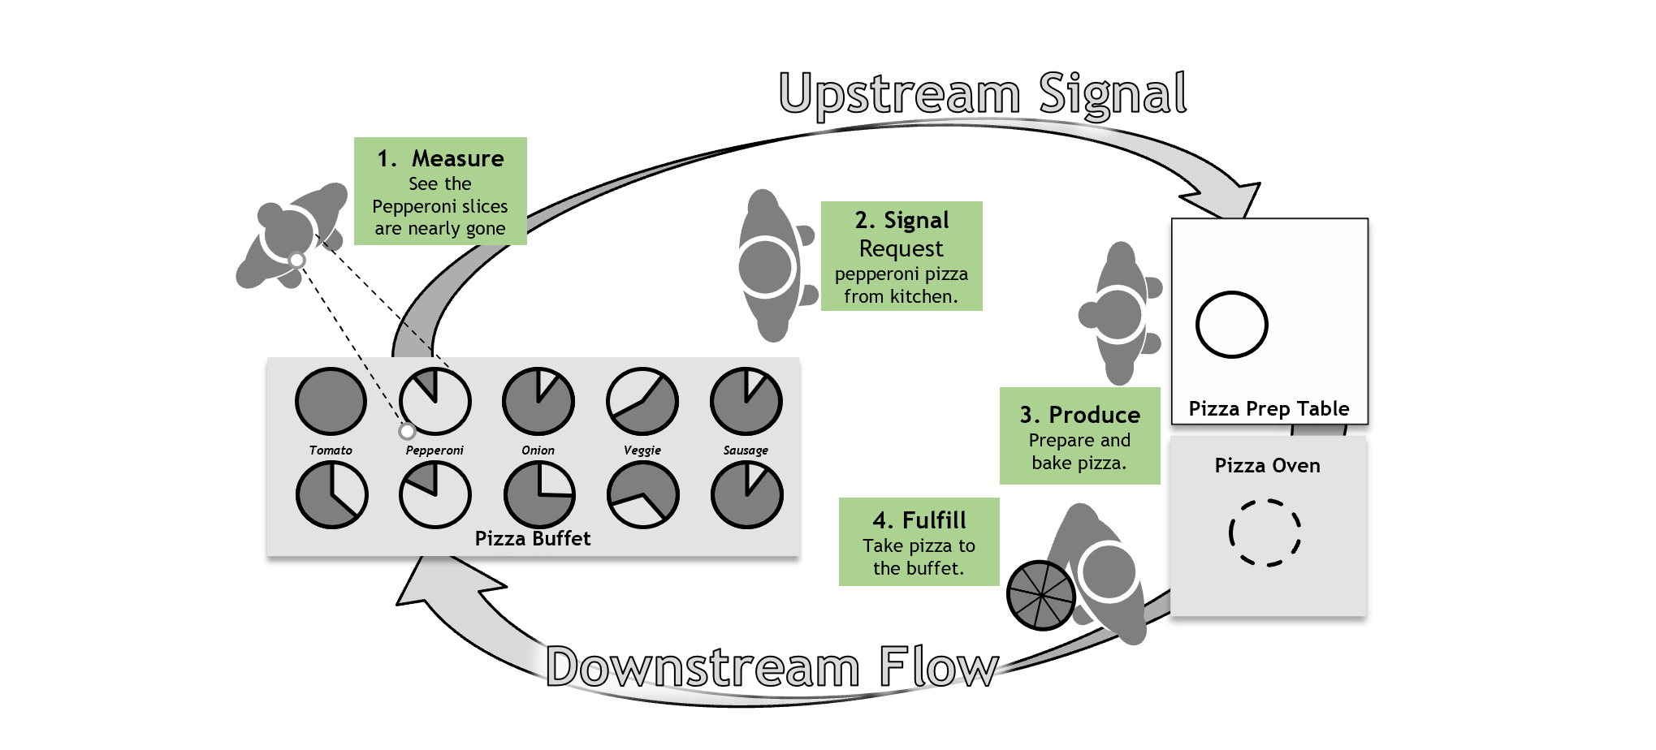
Figure 4. Kanban is similar to a pizza buffet.
No planning meetings. No fixed schedules. Just signals, capacity awareness, and response. This is the essence of a pull system.

Anatomy of a Kanban Board
Kanban boards have been common over the past decade including software applications like Trello, Jira, Microsoft Planner/Lists, and Monday.com. They put tasks in different categories of maturity starting from the least mature on the left (“Backlog”) to the most (“Done”). Figure 5 provides a simple example of a paper system using sticky notes.
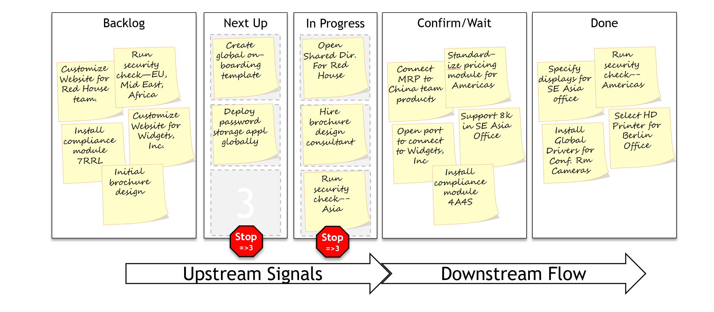
Figure 5. Example Kanban Task Management Board
Each sticky note (“Kanban card”) represents one task.
A typical board includes:
- Backlog – Unlimited pool of requested work
- Next Up – Prioritized queue, ready for execution
- In Progress – Work actively being done
- Awaiting Confirmation – Work completed but pending validation
- Done – Confirmed and finished
Limits are placed on how much can be in “Next Up” and "In Progress" at once — this is critical to create smooth flow.

No Commitments in Backlog
It’s easy to add a new task into the backlog, there is no commitment to complete it. It gets selected (typically in a weekly meeting) only when it’s among the most important tasks in the backlog and so graduates to “Next up”; that might be next week, next month, or never. In a healthy Kanban system, high-value tasks frequently jump the line.
This is one of the most counterintuitive parts of Kanban. Yet many stakeholders act like age in backlog equals priority. I often hear “I’ve been asking for this for six months!” My answer is: if it’s not getting the attention you think it deserves, maybe you need to make a better case as to its importance.

Pulling Work — Not Pushing It
David Anderson emphasizes that limiting WIP (work in progress) and pulling new work only when ready are what make it a true Kanban system. If you have a board with columns and tasks flowing but no limits or signals, it’s just a flashy to-do list.

How Prioritization and Rationalization Work Together
- “Next Up” is where rationalization for the week happens — usually in a quick team meeting with stakeholders
- “In Progress” is where rationalization is enforced — the team should take on no more than they can handle in the coming week or so.
Only the tasks in those two columns are “committed.” Everything in backlog is simply a request.

Estimating Less, Delivering More
Traditional systems rely heavily on estimates:
- Dates are negotiated early
- Misses trigger rework and rescheduling
- Estimation becomes a full-time job
Kanban takes a different route.
A Leaner Alternative
In many teams, every task is a single card — no sizing, no complexity tags, no estimate. Tasks flow one by one.
You don't need to forecast the exact number of hours — just manage the flow:
- When one finishes, the next begins
- Priorities shift easily
- The system stays adaptive

Eliminating Estimation Waste
In a traditional model, a task might:
- Get estimated for later execution
- Change a month later necessitating a new estimate
- Change again two months later necessitating a third estimate
All estimates before the final estimate are waste. Kanban avoids this waste by deferring commitments until the last responsible moment.

Best Fit for Kanban
Kanban works best when:
- Tasks are relatively independent
- Work arrives continuously
- Projects are short or overlapping
Common domains:
- Engineering sustainment
- IT operations
- Custom feature work
- Internal services
When tasks vary in scope but not in flow logic, Kanban simplifies the system and makes overload visible.

Dashboards: Seeing Performance
The Kanban board shows flow.
But it doesn’t show impact.
That’s where dashboards come in:
- Total value delivered (e.g., revenue, savings)
- % of tasks delivered on time
- Backlog growth or shrinkage
- Cycle time per task or project
The Kanban Board and the Dashboard form a complete management system, showing both flow and impact.

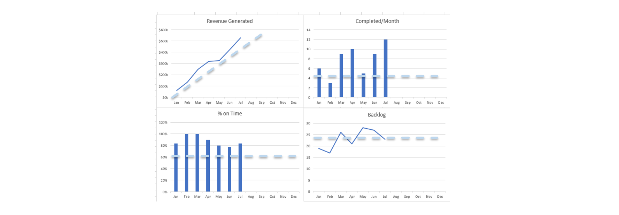
Figure 6. Tracking Performance of a Kanban Board with a Dashboard
“The Kanban board helps us transact work. The dashboard helps us transform how we define success.” — Figure 219

Why Dashboards Matter
At first, teams almost always embrace Kanban because it:
- Reduces chaos
- Clarifies priorities
- Speeds up visible progress
But over time, people forget how bad it was before. Dashboards help maintain momentum:
- Show business impact
- Track improvements
- Guide leadership attention
Starting with Personal Kanban
- Kanban doesn’t require a full team launch. You can start alone.
A Simple Setup
- Create a personal board using:
- 4 sheets of printer paper
- A stack of sticky notes
- Columns like: Backlog, On Deck, Doing, Waiting, Done
- Place it beside your desk where you can’t ignore it. That’s what I did — and I never went back.
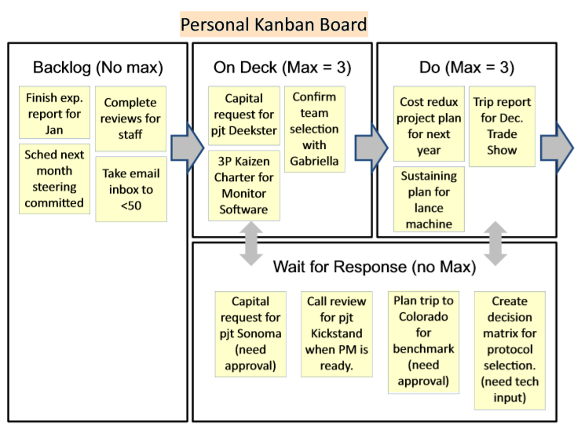
Figure 7. Example of a personal Kanban Board

Immediate Benefits
- Clear visual flow
- Less multitasking
- Faster identification of bottlenecks
- Prioritization becomes visible — even to yourself
- I even added a Waiting on Response column. Why? Because my board flowed in days, but people often took weeks to reply.

Physical vs. Virtual Boards
Choosing between a physical and virtual Kanban board depends on how your team works. For co-located teams, physical boards offer unmatched visibility, immediacy, and spontaneous collaboration — people naturally gather, point, and problem-solve. For distributed teams, virtual boards ensure equal access and clarity across time zones, keeping everyone on the same page. The right choice isn’t about features; it’s about what keeps your team engaged and aligned.

The Case for Physical Boards
- Always visible
- Inviting to collaborators
- Perfect for co-located teams
- People naturally gather around them, point to tasks, suggest solutions. It sparks spontaneous problem-solving. It builds alignment.
- “The physical board had a huge psychological effect compared to anything we got from the electronic tracking tool we used at Microsoft®.” — David Anderson

The Case for Virtual Boards
- Accessible from anywhere
- Fair to remote contributors
- Easier to track across time zones
Virtual boards may lack “presence,” but they provide equity and consistency.

Choose Based on Your Team
- Collocated? Go physical
- Distributed? Go digital
- Don’t get distracted by fancy software. Choose what gets used.

Customizing Kanban for Sustaining Projects
- Most Kanban systems work well for independent tasks that flow through a stable team. But sustaining work is different. It’s often urgent, cross-functional, and scattered across various systems and stakeholders.
Sustaining includes:
- Cost-out efforts
- Quality-driven design changes
- Obsolescence management
- Customer complaints
- Documentation and training updates
- These aren’t side jobs — they’re critical to customer satisfaction, product quality, and operational continuity.

The Challenge with Sustaining Work
Sustaining tasks are:
- Smaller than full-scale projects
- More interrupt-driven
- Often cross-disciplinary
- Rarely tracked as a formal portfolio
- Without a system, they fall between the cracks. Teams overload. Priorities blur. And strategic effort gets buried under reactive noise.

- Customizing the Kanban Card
- To manage sustaining work effectively, start with a better card.
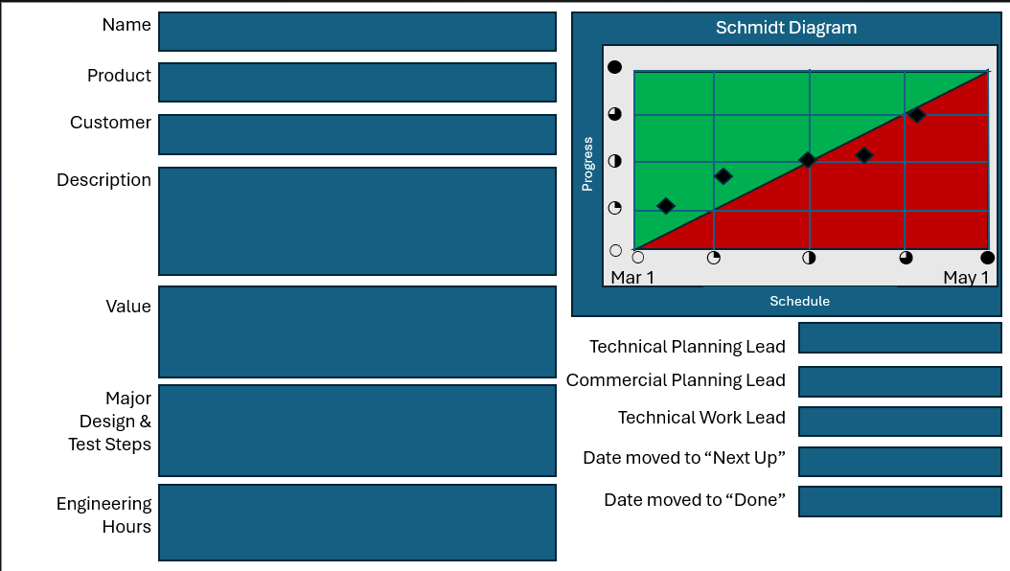
Figure 8. Example Kanban Card for Sustaining Projects
Each card should include:
- Project Title: Clear and concise
- Business Case: Why this matters — customer impact, cost savings, etc.
- KPI Tags: For tracking on-time delivery and business value
- Visual Progress: Simple indicators like checkboxes or stage color. In Figure 8, the Schmidt Chart is shown in the upper right as a quick visual for progress on a simple project.
- Blocking Status: Flag if the task is waiting on another action
This richer card format improves:
- Prioritization during planning
- Hand-offs between functions
- Reporting to leadership

Expanding the Board Layout
Most Kanban boards follow a simple flow: Backlog → In Progress → Done. For sustaining work, consider adding more Kanban categories as shown in Figure 9.
- Prep Column: Where work is clarified before commitment. Rough estimates can can be added so the team knows how much of “Next Up” the task will occupy.
- Release/Acceptance Column: Captures final customer sign-off
- “Wait” Panels: Horizontal swim lanes for tasks that are blocked. The Wait Row makes blockers obvious. It triggers follow-up. It avoids the black hole of “almost done” work that stalls indefinitely.
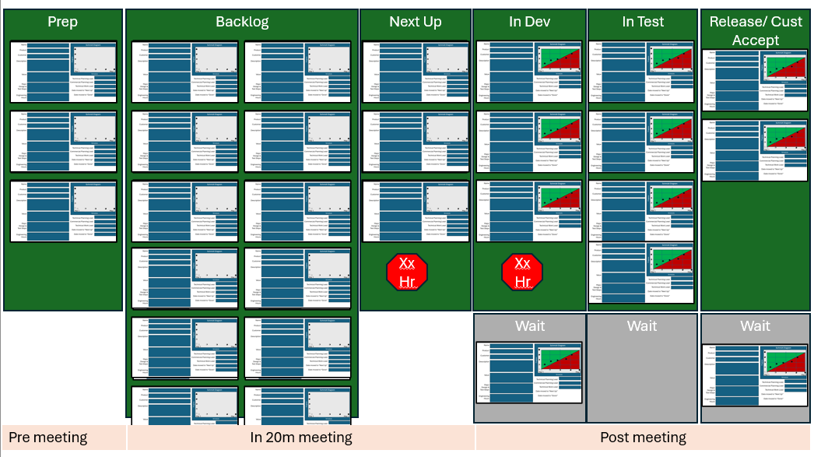
Figure 9. Expanded Kanban Board for Sustaining Projects

Conclusion: Rationalize to Win
Just-in-Time Rationalization and visual flow aren’t just productivity hacks — they’re how teams win in complex, chaotic environments.
When your team:
- Commits to only what they can finish
- Prioritizes based on value, not noise
- Uses a Kanban board to stay aligned and visible
…they create a system where work flows, focus returns, and people thrive.
Add a dashboard, and you unlock a second layer:
- You don’t just get more done — you get the right things done
- You don’t just manage work — you transform how work is chosen
A rationalized workload is more than fair.
It’s powerful, measurable, and motivating.

Kanban: a Lean Thinking Laboratory
The Kanban board provides perhaps the most unambiguous view of the Lean Equation (Chapter 4): over time, you will see the complex interplay of value, effort, and waste. It’s the ideal lab to learn lean thinking. Changes install quickly, and then produce results (or flop) in weeks. The team can improve as they see gaps. This creates what Anderson calls a “Kaizen culture” by empowering people. “Individuals feel free to take actions, free to the do the right thing. They spontaneously swarm on problems,…” I’ve watched this many times. First, an experienced facilitator leads the team to install Kanban. Then, that facilitator stays with the process for a month or two until the team enjoys a little success. Then the team starts changing their board. It never fails—come back a couple of months later and there will be so many changes such as modifying the content of the cards, changing the review team, adding metrics, and on and on. Unlike a heavy product development or business acquisition structure where the stakes for any one project are high, Kanban imparts a right and a duty to experiment in the relatively low risk workflow of small projects.
When starting Kanban, make the fewest possible changes to your existing process. David Anderson said “You must resist the temptation to change workflow, job titles, roles and responsibilities, and specific working practices”. Changing nothing that effects people’s self-esteem or might injure egos. There’s no need. Simply make visible that which is hidden by waste: ambiguous priorities, wasteful multitasking, and persistent barriers.

Conclusion
The Just-in-Time Rationalization simplifies the way we prioritize work. It also can increase engagement. Knowing the team can and will delight their internal customers can be inspiring for those who today go home feeling that no matter how hard they work, they are not meeting the organization’s needs. It connects the internal customers and the staff who execute their tasks by working together to decide what’s most important. It gives a contest that can be won because work is optimally prioritized and constantly rationalized. And it protects the team by ensuring each task is done to completion before starting the next task. The dashboard creates an opportunity to experiment, measuring the value of work and thereby creating opportunities to gain insight on how to improve.

David Anderson, Kanban: Successful Evolutionary Change for your Technology Business, p63.

